Welcome To Worship

____________________________________________________

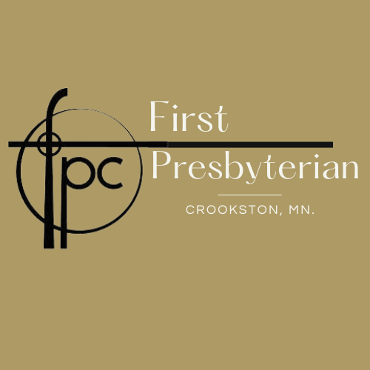

Sunday, September 10th, 2023 15th Sunday After Pentecost

*Those who are able please stand

PREWORSHIP FELLOWSHIP
PRELUDE MUSIC
WELCOME & ANNOUNCEMENTS
MINUTE FOR MISSION
INVITATION TO REST

*OPENING SENTENCES: (Responsive)
Here in this place, there are no others,
for all are welcome in God’s house.
Here in this worship, there is only acceptance,
for all are welcome by God as they are.
Here in our lives, there are no divisions,
for all are welcome as God lives in us.
Come, let us worship in word and then action
with welcome and then love for all.

*GATHERING HYMN #14 For The Beauty Of The Earth

Kyrie #627 I Love You Lord
(Confession does not need to be a somber affair. It can be a joyful and thankful momentr dropping a heavy load from tired hips. God’s grace means confession can sound as much like “hallelujah” as “I’m sorry”. For this reason, we begin and end our “Confession” this morning with “I love you lord”. A joyful song to express how our confessing is also our act of love for the God who already covers us in grace.)
I love you lord And I lift my voice
To worship you oh my soul, rejoice....

CONFESSION OF NEED (Responsive)
Welcoming God,
People are crying I cover my ears
People are dying I dry my eyes
People are my neighbor I see them as threat to my comfort and choose not
love
People are starving I complain about my options
People are oppressed I feel trapped in my routine
People cry out for justice I complain there’s nothing to do
People are so unwell I am sick of the trivial things
People are refugees I feel entitled to better things
People are in poverty I still want more

God,
Listen to my prayers, that I might hear myself,
understand my confession, and find my repentance.
So that I might actually be changed
To help the world do the same. Amen

KYRIE
Take joy my king In what you hear.
May it be a sweat sweat sound In Your ears.

SILENCE for confession and resting In God’s grace.

DECLARATION OF GRACE (Responsive)
You are heard, you are held, you are loved by the God who forgives before we even know to ask. This is the grace poured over us. May you live as drenched people.
Hallelujah! Thanks be to God!

*SHARING THE PEACE OF CHRIST (Responsive)
The Peace of Christ be with you! And Also, with you!
Let us share a sign of God’s peace with one another.

PRAYER FOR ILLUMINATION (Unison)
Holy Spirit, help us hear your voice beyond our inability to hear and understand your word beyond any speaker’s ability to explain. Through your word, speak to our hearts even if our heads are not ready to listen.
Amen.

SCRIPTURE
READING 1............................................................. Romans 13:8-14
READING 2 ............................................................. Matthew 18:15-20
Leader: The word of the Lord. People: Thanks be to God!

SERMON: Pastor Greg Isaacson

(Silence for Reflection)

*HYMN OF THE DAY #515 I Come With Joy

PRAYERS & GIFTS OF THE PEOPLE
Lord in your Mercy. Hear our Prayer.

THE LORD’S PRAYER (forgive us our “sins”)

The Communion

- Invitation

- Prayer of Thanksgiving

- Words of Institution

- Communion of the People

- Prayer

*BLESSING AND CHARGE (Responsive)
Beloved children of God receive the gift of the Holy Spirit, the grace of Jesus Christ, and the blessing of the Lord forever.
Alleluia! Amen.

*CLOSING HYMN #821 How Can I Keep From Singing

*DISMISSAL (Responsive)
Go in peace to love and serve the Lord. Thanks be to God. Amen.

A Warm Welcome to our Guests and Visitors!
Our church has a wonderful array of ministries that seek to spread the gospel into the world. If you are interested in finding out more about the church community or are interested in becoming a member, please contact us at:

Pastor – Rev. Michael Ozaki
Cell: 951.532.5105
PastorOzaki@gmail.com

Office: 218-281-4853 e-mail: crxpres@midconetwork.com
Check out our Website: crookstonfirstpres.org
___________________________________________________

Calendar for this week:

Sunday, September 10, 2023
10:45 am Worship
11:45 am Coffee Fellowship

Ushers & Greeters……………….. Craig & Conner Morgan
Organist....…………..…………….... Caleb Mendez
Music Director……………………... Sandy Perkins
Reader……………………………….... Marsha Odom
Communion Serving & (Prep).. Bill & Gloria Watro / Lori Folkers & (Jeri)

Wednesday, September 9th Thursday, September 10th
6:00pm Bell Rehearsal 1:00 pm New Book Study Begins!

Next Sunday, September 17th
10:45 am Worship
11:45 am Coffee Fellowship

Ushers & Greeters……………… Bill & Gloria Watro
Organist....…………..……………. Caleb Mendez
Music Director…………………… Sandy Perkins
Reader………………………………. Sandy Perkins

A Warm Welcome to our Guests and Visitors!
Our church has a wonderful array of ministries that seek to spread the gospel into the world. If you are interested in finding out more about the church community or are interested in becoming a member, please contact us at:

Pastor – Rev. Michael Ozaki
Cell: 951.532.5105
PastorOzaki@gmail.com

Office: 218-281-4853 e-mail: crxpres@midconetwork.com
Check out our Website: crookstonfirstpres.org
___________________________________________________

Calendar for this week:

Sunday, September 10, 2023
10:45 am Worship
11:45 am Coffee Fellowship

Ushers & Greeters……………….. Craig & Conner Morgan
Organist....…………..…………….... Caleb Mendez
Music Director……………………... Sandy Perkins
Reader……………………………….... Marsha Odom
Communion Serving & (Prep).. Bill & Gloria Watro / Lori Folkers & (Jeri)

Wednesday, September 9th Thursday, September 10th
6:00pm Bell Rehearsal 1:00 pm New Book Study Begins!

Next Sunday, September 17th
10:45 am Worship
11:45 am Coffee Fellowship

Ushers & Greeters……………… Bill & Gloria Watro
Organist....…………..……………. Caleb Mendez
Music Director…………………… Sandy Perkins
Reader………………………………. Sandy Perkins

