Welcome To Worship
_______________________________________________
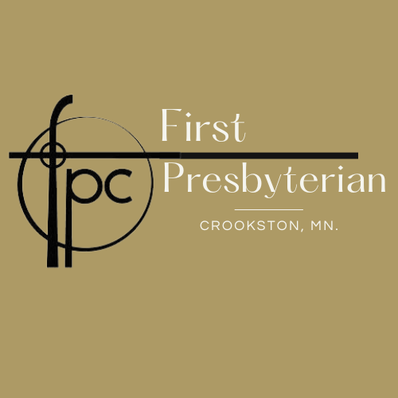

Sunday, Augus 20th, 2023/ 12th Sunday After Pentecost
*Those who are able may stand
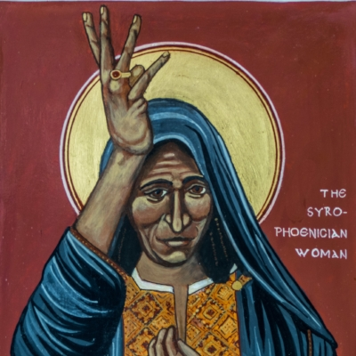

PREWORSHIP FELLOWSHIP
PRELUDE MUSIC
WELCOME & ANNOUNCEMENTS
AN INVITATION TO REST

*OPENING SENTENCES (Responsive)
Thus says the Lord:
Maintain justice, and do what is right,
For soon my salvation will come.
God will bring us to the holy mountain,
A house of prayer for all people.
God gathers all the outcasts together,
And makes us joyful.

*GATHERING HYMN # Syrophoenician Woman by Rober Lenzruth

KYRIE
(Please join us in the “Kyrie”, an ancient song that mirrors the words people used to cry out to Jesus for healing in the scriptures. In Greek they mean, “Lord, have mercy”. The church has sung these words for thousands of years as prayer and to prepare our hearts for confession.)

Kyrie Eleison (Lord have mercy) Kyrie Eleison
Christe Eleison (Christ have mercy) Christe Eleison
Kyrie Eleison (Lord have mercy) Kyrie Eleison

CONFESSION OF NEED (Unison)
God of all goodness,
We do not want to face all that is in our own hearts.
We want to focus on the good
On the love, the compassion, the care
And ignore the bad, the greed, the envy, the cruelty.
But before you, God, we must face it.
Forgive all the ways we have let evil take hold in our hearts.
Cleanse us. Help us face our own demons,
And empower us to live
A Christlike life.

KYRIE
Kyrie Eleison (Lord have mercy) Kyrie Eleison
Christe Eleison (Christ have mercy) Christe Eleison
Kyrie Eleison (Lord have mercy) Kyrie Eleison

SILENCE for confession and resting In God’s grace.

DECLARATION OF GRACE (Responsive)
We have been disobedient to God,
But we have received mercy.
Let us live our lives as those transformed
By the abundant mercy of God!

*RESPONSE HYMN #

*SHARING THE PEACE OF CHRIST (Responsive)
The Peace of Christ be with you! And Also, with you!
Let us share a sign of God’s peace with one another.

PRAYER FOR ILLUMINATION (Unison)
Holy Spirit, help us hear your voice beyond our inability to hear and understand your word beyond any speaker’s ability to explain. Through your word, speak to our hearts even if our heads are not ready to listen.
Amen.

SCRIPTURE READING 1…………..…………………....Isaiah 56: 1, 6-8
READING 2...................................Matthew 15:21-28
Leader: The word of the Lord. People: Thanks be to God!

SERMON..........................................................Pr. Greg Isaacson

Silence for Contemplation

PRAYERS & GIFTS OF THE PEOPLE
Lord in your Mercy. Hear our Prayer.

THE LORD’S PRAYER (forgive us our “sins”)

*BLESSING AND CHARGE (Responsive)
Beloved children of God receive the gift of the Holy Spirit, the grace of Jesus Christ, and the blessing of the Lord forever.
Alleluia! Amen.

*CLOSING HYMN #

*DISMISSAL (Responsive)
Go in peace to love and serve the Lord. Thanks be to God. Amen.

*POSTLUDE

A Warm Welcome to our Guests and Visitors!
Our church has a wonderful array of ministries that seek to spread the gospel into the world. If you are interested in finding out more about the church community or are interested in becoming a member, please contact us at:

Pastor – Rev. Michael Ozaki
Cell: 951.532.5105
PastorOzaki@gmail.com

Office: 218-281-4853 e-mail: crxpres@midconetwork.com
Check out our Website: crookstonfirstpres.org
__________________________________________________

Calendar for this week: Sunday, August 20, 2023
10:45 am Worship
12:00 pm Coffee Fellowship

Preaching………………………….. Rev. Greg Isaacson
Ushers & Greeters……………… Marsha Odom & Marlys Mjoen
Organist....…………..……………. Hannah Kruger
Music Director…………………… Sandy Perkins
Reader………………………………. Sandy Perkins

Next Sunday, August 27th
10:45 am Worship
11:45 am Coffee Fellowship

Preaching………………………….. Rev. Greg Isaacson
Ushers & Greeters……………… Dan & Laurie Wilson
Organist....…………..……………. Hannah Kruger
Music Director…………………… Sandy Perkins
Reader………………………………. Marsha Odem

A Warm Welcome to our Guests and Visitors!
Our church has a wonderful array of ministries that seek to spread the gospel into the world. If you are interested in finding out more about the church community or are interested in becoming a member, please contact us at:

Pastor – Rev. Michael Ozaki
Cell: 951.532.5105
PastorOzaki@gmail.com

Office: 218-281-4853 e-mail: crxpres@midconetwork.com
Check out our Website: crookstonfirstpres.org
__________________________________________________

Calendar for this week: Sunday, August 20, 2023
10:45 am Worship
12:00 pm Coffee Fellowship

Preaching………………………….. Rev. Greg Isaacson
Ushers & Greeters……………… Marsha Odom & Marlys Mjoen
Organist....…………..……………. Hannah Kruger
Music Director…………………… Sandy Perkins
Reader………………………………. Sandy Perkins

Next Sunday, August 27th
10:45 am Worship
11:45 am Coffee Fellowship

Preaching………………………….. Rev. Greg Isaacson
Ushers & Greeters……………… Dan & Laurie Wilson
Organist....…………..……………. Hannah Kruger
Music Director…………………… Sandy Perkins
Reader………………………………. Marsha Odem

