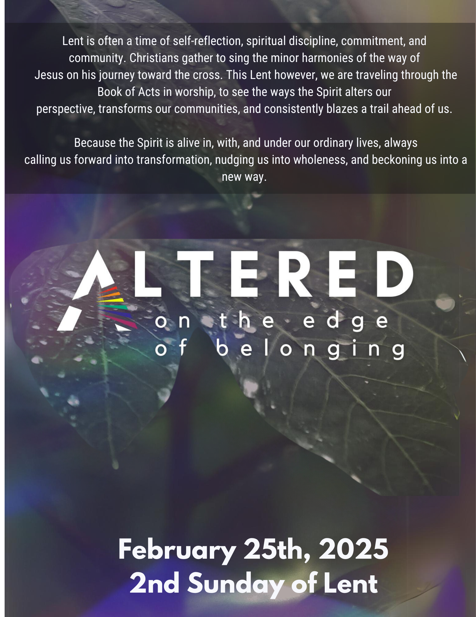

PRELUDE MUSIC
WELCOME & ANNOUNCEMENTS
INVITATION TO REST:

*OPENING SENTENCES: (Psalm 22)
On this second Sunday of lent we come:
To worship the one enthroned on the praise of God’s people.
As our ancestors trusted; and God delivered.
They cried out, and were saved;
they remembered and were not put to shame.
So let us lift up our voices and hands in prayer,
Come near Christ Jesus, we are here to worship you.

*GATHERING HYMN #319 Shout to The North

KYRIE (Please join us in the “Kyrie”. an ancient song mirroring the words people cried out to Jesus with for healing in the Gospels. In Greek they mean, “Lord, have mercy. Christ Have Mercy”. The church has sung these words for thousands of years as a prayer and to prepare our hearts for confession.)

Lead: Kyrie Eleison (Lord have mercy) All: Kyrie Eleison
Lead: Christe Eleison (Christ have mercy) All: Christe Eleison
Lead: Kyrie Eleison (Lord Have Mercy) All: Kyrie Eleison

CONFESSION of Need (Responsive)
Trinitarian God, Three in One, we confess that we still struggle with belonging. With feeling, trusting it and especially extending it to others.
While you show us belonging and inclusion in perfect balance. Made in your image, we long for community, yet in our insecurity and fear, we retreat into rigid categories and us/ them thinking, as if excluding others could protect us from being left out. While we know that in You, there is no inside or outside; in You, there is no us or them, we struggle to drop these tired and tribal habits.

And so, we ask you to sear the truths we need upon our hearts:

As Children of God, you are enough.
lovable as you are,
and God will love you as you change and grow.
Where there is fear, give us courage.
Where there is doubt, give us faith.

As children of God, your neighbors are enough.
They are lovable as they are,
and God will love them as they change and grow.
Where there is fear, give us courage.
Where there is doubt, give us faith.

As children of God, your enemies are enough.
They are lovable as they are,
and God will love them as they change and grow.
Where there is fear, give us courage.
Where there is doubt, give us faith.

Children of God, the Creator has been, and will be.
There is no test to pass,
no score to keep,
no border to cross;
You have already arrived, and you can rest here.
In the arms of one strong enough to bring you where you need to be,
Christ Jesus Our Lord, Amen.

Lead: Kyrie Eleison (Lord have mercy) All: Kyrie Eleison
Lead: Christe Eleison (Christ have mercy) All: Christe Eleison
Lead: Kyrie Eleison (Lord Have Mercy) All: Kyrie Eleison

SILENCE for confession and resting In God’s grace.

DECLARATION OF GRACE
Hear the good news! Who is in a position to condemn? Only Christ, and Christ died for us, Christ rose for us, Christ reigns in power for us, Christ prays for us. Anyone who is in Christ is a new creation. The old life has gone; a new life has begun.
Believe the good news of the Gospel: In Jesus Christ we are forgiven.
Thanks be to God, Amen!
*RESPONSE HYMN #519 You Are My Strength
SHARING OF THE PEACE

*PRAYER FOR ILLUMINATION (Unison)
Holy Spirit, help us hear your voice beyond our inability to hear and understand your word beyond any speaker’s ability to explain. Through your word, speak to our hearts even if our heads are not ready to listen. Amen.

SCRIPTURE READING ........................................................................Acts 8: 26-40
Leader: The word of the Lord. People: Thanks be to God!

*SERMON......................................................................................Pastor Mike Ozaki
SILENCE FOR CONTEMPLATION

*CONTEMPLATION HYMN: #726 Will You Come and Follow Me (v. 1,4,5)

PRAYERS & GIFTS OF THE PEOPLE
Lord in your Mercy. Hear our Prayer.

THE LORD’S PRAYER (forgive us our “sins”)

*BLESSING AND CHARGE (Responsive)
Beloved children of God receive the gift of the Holy Spirit, the grace of Jesus Christ, and the blessing of the Lord forever.
Alleluia! Amen.

*CLOSING HYMN #216 Beneath the Cross of Jesus (v. 1,3)

*DISMISSAL (Responsive)
Go in peace to love and serve the Lord. Thanks be to God. Amen.

*POSTLUDE
A Warm Welcome to our Guests and Visitors!
Our church has a wonderful array of ministries that seek to spread the gospel into the world. If you are interested in finding out more about the church community or are interested in becoming a member, please contact us at:

Pastor – Rev. Michael Ozaki
Cell: 951.532.5105
PastorOzaki@gmail.com

Office Administrator – Anne Kopecky Office: 218-281-4853
E-mail: office@crookstonfirstpres.org
Check out our website: www.crookstonfirstpres.org
__________________________________________________

Sunday- February 25th , 2024
10:45 am Worship
11:45 am Vision & Values Retreat Report

Ushers & Greeters……………....… Craig & Connor Morgan
Organist....…………...……………. George French
Vocalist...............................................Marley Melby
Music Director...……………………Sandy Perkins
Reader.……………………………...Sandy Perkins

Wednesday -February 28th, 2024 Thursday February 22nd, 2024 5:30pm- Lenten Food & Reflections 1:00pm- Book Study “Pause”

Next Sunday- March 3rd, 2024
10:45 am Worship
11:45 am Coffee Fellowship

Ushers & Greeters……………....…Mario & Jill Schisano
Organist....…………..…………….. George French
Music Director..…………………… Sandy Perkins
Reader.…………………………….. Marsha Odom
Communion Servers & Prep.......... Gordie & Monica Terpstra
Special Announcements!
Lenten Soup & Reflections
Wednesdays @ 5:30-7:00, Feb. 21st – March 27th
We are looking forward to our second Lenten gathering with food and reflections to chew on together.
BUT FIRST!
We have one spot left for someone to provide a pot of comfort
food for us to share together. If that’s you, please fill out the sign-up sheet outside the sanctuary or contact the office to let us know if you plan to help out in this way.

Vision & Values Retreat Report!
At Social Hour After Worship This Sunday

Join us after worship to hear about the outcomes of
last month’s “Congregational Values and Vision Retreat”
and how it will shape the focus of FPC in the near future.
Holy Doodles

