Welcome To Worship
4thSunday after Epiphany

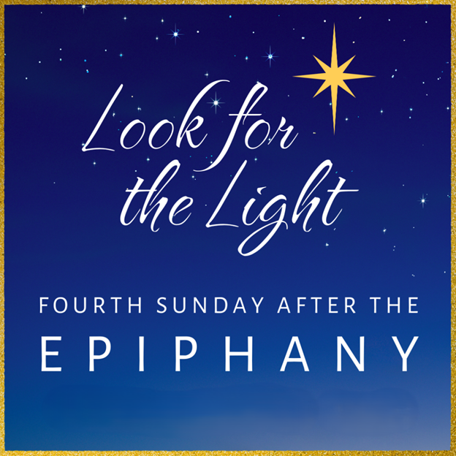



February 1st, 2026

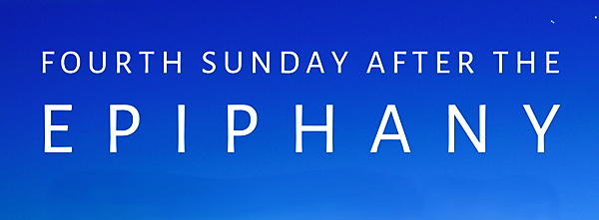

PRELUDE MUSIC: “Seek Ye First” – The Joyful Ringers Bell Choir
WELCOME AND ANNOUNCEMENTS
CALL TO WORSHIP:
Beloved, what worship does God desire of us?
To do justice, love kindness, and live humbly with God.
In our life together as the body of Christ, what worship does God desire of us?
To do justice, love kindness, and live humbly with God.
When we share the good news with all creation, what worship does God desire of us?
To do justice, love kindness, and live humbly with God.
Come, let us worship God with justice, kindness, and humility!
We come to worship God with our voices and our lives. Thanks be to God! Amen.
OPENING HYMN: #664 “Morning Has Broken”

PRAYER OF CONFESSION
Micah reminds us that our prayers, fasting, and pious ritual
must be lived out in compassion and justice:
When we forget the fast you desire—
To do justice, and rise up for the powerless:
Lord, have mercy.
When we forget the prayer you love—
To show compassion and care for those in need:
Christ, have mercy.
When we forget the rituals you require—
To create relationships of righteousness and peace:
Lord have mercy.
Assurance of Grace and Peace
Friends, the love of God revealed in Jesus
forgives us, heals us, and sets us free
to rebuild, restore, and
raise up foundations for new beginnings.
RESPONSE HYMN: #519 “You are My All in All”

SHARING THE PEACE OF CHRIST (Responsive)
The Peace of Christ be with you! And Also, with you!
Let us share a sign of God’s peace with one another.

SPECIAL MUSIC: “As The Deer” The Joyful Ringers Bell Choir

PRAYER OF ILLUMINATION
Holy God, our hope and strength, by the power of your Spirit
prepare the way in our hearts for the coming of your Word,
so that we may see the glorious signs of your promise fulfilled;
through Jesus Christ our Lord. Amen.

SCRIPTURE
Reading #1..................................................Micah 6: 1-8
Reading #2..................................................1 Corinthians 1: 18-31
Gospel Reading...........................................Matthew 5: 1-12
Leader: This is the Word of God for the people of God. All: Thanks be to God!
MESSAGE Pastor Mike Ozaki

MOMENT OF REFLECTION

HYMN OF PREPARATION: #769 “For Everyone Born” (Vs. 1-3)

PRAYERS & GIFTS OF THE PEOPLE
Lord in your mercy. Hear our prayer.

LORD’S PRAYER (forgive us our “sins”)


COMMUNION
- Invitation - Prayer of Thanksgiving - Words of Institution - Communion of the People - Prayer
BLESSING AND CHARGE (Responsive)
Beloved children of God receive the gift of the Holy Spirit, the grace of Jesus Christ, and the blessing of the Lord forever.
Alleluia! Amen.

CLOSING HYMN: #769 “For Everyone Born” (Vs. 4-5)

BENEDICTION
God is our light, our hope, our all in all:
Blessed be God, now and forever!
Christ is our home, our life, our joy:
Blessed be God, now and forever!
Our worship concludes; our service continues.
Blessed be God, now and forever!
DISMISSAL (Responsive)
Go in peace to love and serve the Lord. Thanks be to God. Amen.

POSTLUDE (Please stay seated and enjoy the music from our talented musicians)

February 1st-February 8th, 2026
_________________________________________________

Sunday- February 1st, 2026

10:45 am Worship
11:45 am Coffee Fellowship
Message....…………..……………..Mike Ozaki
Ushers & Greeters…………….......Wally Hoselton & Craig Morgan
Pianist....…………..……………..George French
Music Director..…………………...Sandy Perkins
Reader.…………………………….Lynne Mullins
Communion Server............................Gary Hoerner
Communion Preparer..............................Marlys M.

Wednesday- February 4th, 2026

6:00pm – Bell Choir

Thursday- February 5th, 2026

1:00pm - Bible Study at Trinity Lutheran in Library

Next Sunday- February 8th, 2026

10:45 am Worship
11:45 am Coffee Fellowship
Message....…………..……………..Marley Melbye
Ushers & Greeters…………….......Sandy Perkins & Jeri Melsa
Pianist....…………..……………..George French
Music Director..…………………...Sandy Perkins
Reader.…………………………….Marsha Odom

