***Welcome To Worship***

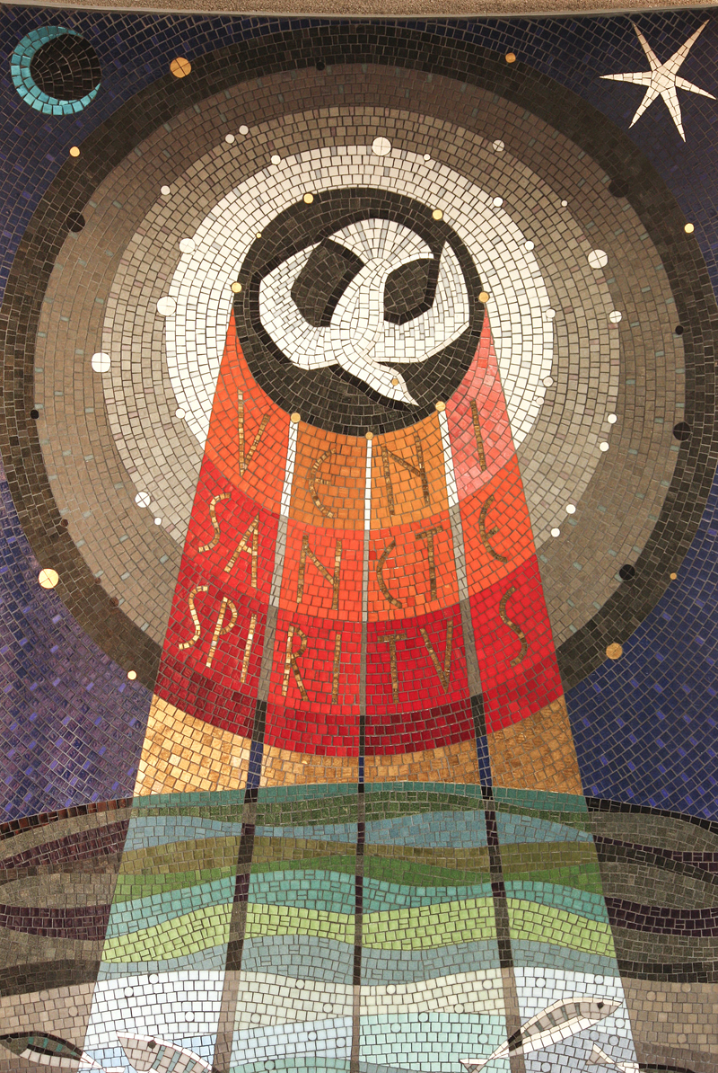

***July13th, 2025***

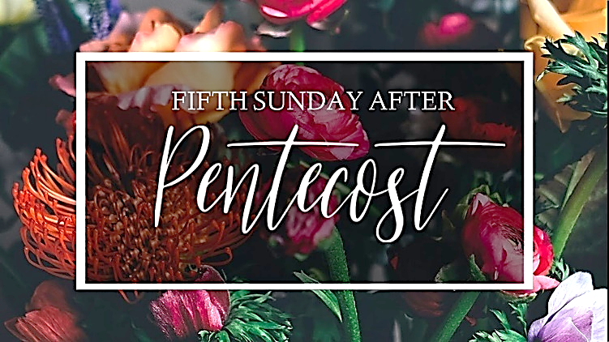

**PRELUDE MUSIC**

**WELCOME & ANNOUNCEMENTS**

**INVITATION TO REST**

**OPENING SENTENCES FROM PSALM 148 (Responsive)**

We come with willing hearts and eager minds.  
**Lead us in your truth, O God of our salvation!**  
We come in our weakness and wander**.**  
**Teach us your ways,**  
**O God of our salvation!**  
We come seeking the path of justice.  
**We are ready to follow,**  
**O God of our salvation!**

**GATHERING HYMN**  **#41** **O Worship The King (Vs. 1,2 & 4)**

**KYRIE #695 Change My Heart O God.**

*(We Begin with “Alleluia” because our confession is also our act of loving thanks to the God who already covers us in grace.)*

***Change my heart O God, and make it ever new***

***Change my heart O God, May it be like you.***

**CONFESSION OF NEED (Responsive)**

**Gracious God,**  
**Jesus tells us that our lives are enriched**  
**by loving you and loving our neighbors.**  
**We confess that love is hard for us.**  
**We are too selfish or too pessimistic,**  
**too hollow or too hardened,**  
**or just too tired**  
**to give ourselves to love’s demands.**  
**Forgive our arrogance and our listlessness.**  
**Cleanse our hearts**  
**that we might find the strength**  
**to do what love requires**  
**and the grace to receive**  
**what love has to give.**  
**We pray in the name of Jesus,**  
**whose love has no boundary. Amen.**

***SILENCE for confession and resting In God’s grace.***

**KYRIE**

***Change my heart O God, and make it ever new***

***Change my heart O God, May it be like you.***

**DECLARATION OF GRACE (responsive)**

Mercy ceaselessly flows from the heart of God.  
 This is good news!  
 **In Jesus Christ we are forgiven!**

**RESPONSE HYMN**  **#591** **Halle Halle Hallelujah**

**SHARING THE PEACE OF CHRIST (Responsive)**

The Peace of Christ be with you! **And Also, with you!**

Let us share a sign of God’s peace with one another.

 

**PRAYER FOR ILLUMINATION (Unison)**

**Holy Spirit, help us hear your voice beyond our inability to hear and understand**  **your word beyond any speaker’s ability to explain. Through your word, speak to our hearts even if our heads are not ready to listen.**

**Amen.**

**SCRIPTURE**

Reading #1............................................................ Amos 7:7-17

Reading #2............................................................ Luke 10:25-37

*Leader: The word of the Lord.* **People: Thanks be to God!**

**MESSAGE.................................................................................... Rev. Curt Peterson**

**SILENCE FOR CONTEMPLATION**

**CONTEMPLATION HYMN:**   **#740** **Lead Me Guide Me**

**PRAYERS & GIFTS OF THE PEOPLE**

Lord in your Mercy. **Hear our Prayer.**

**THE LORD’S PRAYER (forgive us our “sins”)**

**BLESSING AND CHARGE (Responsive)**

Beloved children of God receive the gift of the Holy Spirit, the grace of Jesus Christ, and the blessing of the Lord forever.

**Alleluia! Amen.**

**CLOSING HYMN**  **#634** **To God Be The Glory**

**DISMISSAL (Responsive)**

Go in peace to love and serve the Lord. **Thanks be to God. Amen.**

**POSTLUDE**



A Warm Welcome to our Guests and Visitors!

*If you are interested in finding out more about the church community or are interested in becoming a member, please contact us at:*

**Pastor – Rev. Michael Ozaki**

**Cell: 951.532.5105**

[*PastorOzaki@gmail.com*](mailto:PastorOzaki@gmail.com)

**Office Administrator – Anne Kopecky Office: 218-281-4853**

**E-mail:** [**office@crookstonfirstpres.org**](mailto:office@crookstonfirstpres.org)

**Check out our Website:** [**www.crookstonfirstpres.org**](http://www.crookstonfirstpres.org/)

**__________________________________________________**

**Sunday- July 13th, 2025**

**10:45 am** **Worship**

**11:45 am**  **Coffee Fellowship**

**Ushers & Greeters……………...... Bruce & Jody Hanson**

**Organist....…………..……………....Hazel Mendez**

**Music Director..…………………...Sandy Perkins**

**Reader.……………………………....Marsha Odom**

**Next Sunday-** **July 20th, 2025**

**10:45 am** **Worship**

**11:45 am**  **Coffee Fellowship**

**Ushers & Greeters…………….......Wally & JoAnn Hoselton**

**Pianist....…………..……………..Anne Kopecky**

**Music Director..…………………...Sandy Perkins**

**Reader.…………………………….Lynne Mullins**



